

SEMESTER 2 EXAMINATION 2011/2012

Agent Oriented Software

COMP40040

Mr J. Dunnion
Dr. R. Collier*

Time allowed: 2 hours

Instructions for candidates

Answer question one and one other question

1. Answer parts (a) to (g). 50 marks in total

- What is an agent? Include in your answer the key features that an agent should exhibit and draw a diagram that illustrates the typical architecture of an agent that meets the requirements of this definition.
(6 marks).
Definition (3 marks)

“an encapsulated computer system, situated in some environment, and capable of flexible autonomous action in that environment in order to meet its design objectives.”

- Autonomous: Control over internal state and own behaviour.
- Situated: Experiences environment through sensors and acts through effectors.
- Flexible:
  - Reactive: Respond in a timely fashion to environmental change.
  - Proactive: Act in anticipation of future goals.

Diagram (3 marks)
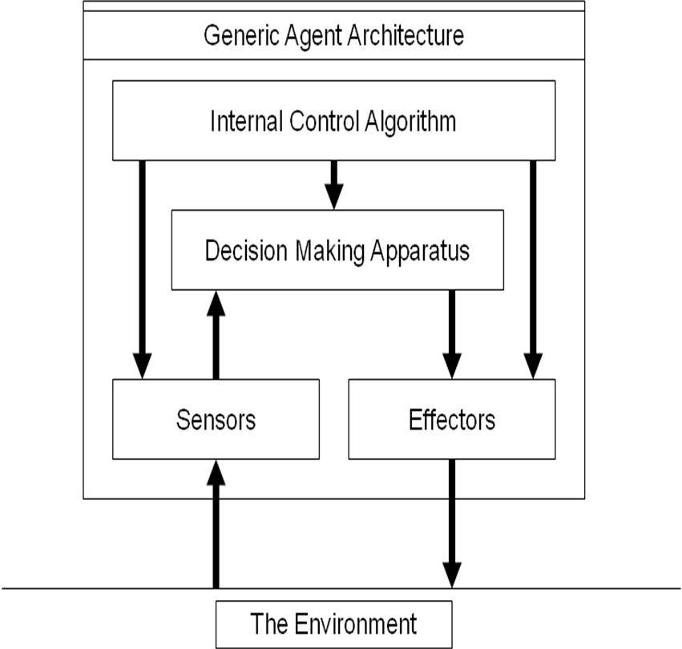

- AgentSpeak(L) is considered the first Agent-Oriented Programming language to implement a form of the BDI architecture. The language is said to be event-driven. What does this mean? What types of event exist in the language?
(4 marks).
2 marks:

What it means is that behavior is driven by the consumption of events that lead to the adoption / refinement of intentions.

2 marks (1 per event type):
External Events: events generated through the addition / removal of beliefs
Internal Events: events generates through the posting of new goals.

- Explain what the following AgentSpeak(L) program does:

+hungry(me) : have(?x) & is(?x, food) & like(?x) <-
!eat(?x),
!throw(leftOvers);

+!throw(?trash) : bin(full) <-
!empty(bin),
!throw(?trash);

+!throw(?trash) : ~bin(full) <-
put(?trash, bin);
(6 marks).
2 marks per rule

- “The Agent-Oriented Programming (AOP) paradigm can be viewed as a specialization of the Object Oriented Programming paradigm in which systems are built using agents.” Give Shoham’s table of comparison for AOP and OOP.
(10 marks).

Replicate table from notes:

OOP AOP
Basic Unit Object Agent
Parameters describing unconstrained beliefs, commitments,
state of basic unit capabilities
Process of Computation message passing and message passing and
response methods response methods
Types of Message unconstrained inform, request, offer
Constrains on Methods none honesty, consistency

- Agent-Oriented Programming is typically viewed as a form of logic programming that is based on complex multi-modal logics. The underlying theory behind these logics is based on the philosophical theories of Dennett. Dennett’s core idea is that the behavior of an object can be explained at different levels of abstraction (or stances). List and describe the three stances.
(9 marks).

3 marks per stance
Three levels of abstraction can be used to predict and explain the behaviour of an object:
  - Physical Stance: the domain of physics and chemistry; concerned with mass, energy, velocity, chemical composition, …
    - Predicting where a ball will land based on trajectory
  - Design Stance: the domain of biology and engineering; concerned with purpose, function and design.
    - Predicting that a bird will fly when flapping its wings because this is what wings are for
  - Intentional Stance: the domain of software and minds; concerned with belief, thinking, and intent.
    - Predicting that the bird will fly away because it knows the cat is coming and it is afraid of being eaten.

- GAIA is a methodology that supports systems analysis and design using the multi-agent systems metaphor. One of the central models in the analysis phase is the roles model, which consists of a set of roles defined using a role schema template. List and explain the purpose of the fields that make up this schema.
(5 marks).

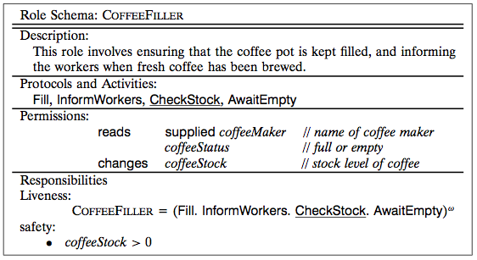

- Give a detailed description of the notions of permission and responsibility in GAIA.
(10 marks).

Permissions (5 marks):
- Permissions specify resource requirements for roles:
  - What resources that can legitimately be used to carry out the role (I.e. what can be spent), and
  - What are the resource limits within which the role executor must operate (I.e. what cannot be spent).
  - While, in practice, resources may take many forms (e.g. money, man-hours effort), GAIA adopts the view of a resource as “the information or knowledge the agent has”.
  - That is, in order to carry out a role, an agent will typically be able to access certain information.
    - Some roles might generate information;
    - Others may need to access a piece of information, but not modify it;
    - Thus, permissions are defined as access rights for pieces of information!
- The types of permission allowed in GAIA are:
  - Read Access. The role must be able to access the specified information, but does not need to modify that information.
    - E.g. reads coffeeStatus
  - Write Access. The role must be able to modify the value of the specified information.
    - E.g. changes coffeeStock
  - Create Access. The role creates/generates the specified information.
    - E.g. generates coffeeStatus
- In addition, GAIA supports role templatisation through the parameterisation of permissions.
  - That is, it is possible to supply a role with information.
    - E.g. reads supplied coffeeMaker

Responsibilities (5marks):

- Responsibilities define the functionality required by the role. They are divided into two categories:
  - Liveness Responsibilities. Those that, intuitively, state that “something good happens”. That is, they specify what must be done.
  - Safety Responsibilities. Those that, intuitively, state that “nothing bad happens”. That is, they specify invariants that must be maintained during the execution of the role.
- Liveness responsibilities are things that the agent must do while playing the role.
- As such, they tend to follow certain patterns. For example:
  - Guaranteed Response type achievement goals take the form “a request is always followed by a response”.
  - Infinite Repetition type achievement goals take the form “x will happen infinitely often”.
- In the context of a coffee maker, liveness responsibilities include:
  - whenever the coffee pot is empty, fill it up; and
  - whenever fresh coffee is brewed, make sure the workers know about it.
- GAIA represents liveness properties as liveness expressions. These are basically regular expressions.
- A liveness expression takes the form
ROLENAME = expression
where, ROLENAME is the name of the role and expression is the liveness expression.
- The atomic components of a liveness expression are either activities or protocols.
  - Activities are fundamental actions that must be directly executable by the agent. They are represented here by activity identifiers.
  - Protocols define interactions with other roles. These are defined in the Interaction Model. They are represented here by protocol identifiers.
- These atomic components can be combined with a number of operators to form the liveness expressions.
- Safety responsibilities define invariants that must remain true during the execution of the role.
  - These invariants take the form of predicate expressions that define constraints which apply to the variables listed in the permissions field of a role.
  - For example, the invariant that the coffee stock is never empty can be represented by the following safety expression:
coffeeStock > 0
- It is implicitly assumed that these responsibilities will apply across all states of the system execution.
- If the role is infinitely long, then the invariant will always remain true.

2. Answer parts (a) to (e). 50 marks in total

- Describe the general principle of message-passing based communication. What are the advantages and disadvantages of this approach to communicatin?
(10 marks)

- General Principle: (4 marks)
  - Messages sent directly receiver agent (1:1 communication).
  - Message transmission handled by a communication channel.
  - Message format based on an agreed communication language.
  - Interaction consists of several messages where the agents take their turns as sender and receiver.
  - This is called a dialog or a protocol.
  - This model of message-passing is more traditional:
    - Modern message-oriented middleware supports factures such as: presence management, message persistence, security, multcast, publish/subscribe, …
- Advantages: (3 marks)
  - Well suited to internet scale applications.
  - Communication is directed to relevant agents (no information overload).
  - More Robust: So long as the communication channel is decentralised.
- Disadvantages: (3 marks)
  - Agent Discovery: new agents must register their existence.
  - Choosing an appropriate communication language.
  - Defining and enforcing protocols.

- What is Speech Act Theory? List and explain the five main categories of speech act as identified by Searle.
(14 marks)

- Definition (4 marks):
  - The origin of speech act theories are usually traced to the work of the philosopher John Austin.
  - Austin noticed that some utterances are like ”physical actions” that appear to change the state of the world. e.g.
    - Declaring war
    - ”I now pronounce you man and wife”
  - Austin distinguished 3 different aspects of speech acts:
    - Locutionary act - act of making an utterance
      - e.g. saying ”please make some tea” ’
    - Illocutionary act – action performed in saying something
      - e.g. he requested me to make some tea
    - Perlocution – effect of the act
      - e.g. he got me to make tea
- Categories (10 marks):
  - Representatives or assertives (informing)
  - Directives (requesting)
  - Commisives (committing)
  - Expressive (express a mental state)
  - Declaratives (effect some change)

- What is an Agent Communication Language (ACL)? What is the minimum set of features required for a functioning ACL? Why is this insufficient in practice?
(6 marks)

- An Agent Communication Language combines:
  - a data format for representing speech acts.
  - a (partial) model of the state of the speaker and hearer.
  - a formally specified set of speech act types (based on the above model).

- Minimal Practical Form: performative, sender, receiver, content
  - request ( rem, bob ) “closed(door)”

- In theory:
  - speech act = performative verb + propositional content.

- In practice:
  - Contextual information, such as: who performed the speech act, and to whom it was directed.

- Draw Agent UML Protocol Diagrams for the FIPA Request Protocol and the FIPA Subscribe Protocol. Explain in words how each protocol works.
(20 marks)

10 marks per protocol
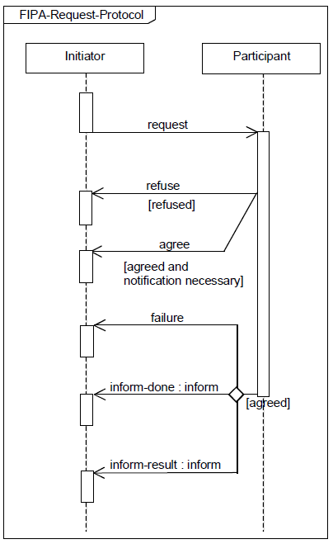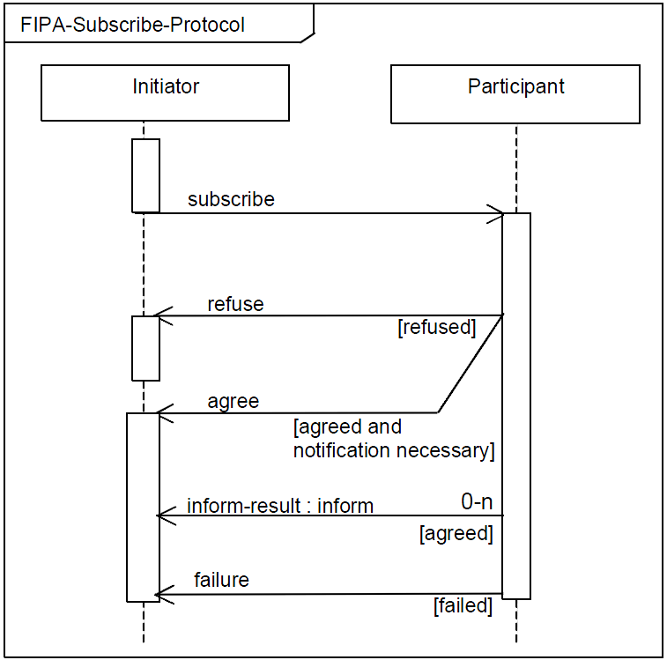

3. Answer parts (a) to (e). 50 marks in total

- What is Coordination? List the reasons why you may need to use coordination.
(13 marks)

Definition (3 marks):
”The process by which an agent reasons about its local actions and the (anticipated) actions of others to try and ensure that the community acts in a coherent manner.”

Reasons (2 marks per reason):

- Preventing anarchy or chaos
- Dependencies between agents’ actions.
- Need to meet global constraints
- No individual has sufficient competence, resources or information to solve the entire problem.
- Efficiency

- Two basic approaches to coordination are task sharing and result sharing. Describe, using examples, both of these approaches
(10 marks)

Task Sharing (2 marks): When a problem isdecomposed into subproblems and allocated to different agents.

Result Sharing (2 marks): When agents share information relevant to their subproblems

3 marks per example

- One issue that is increasingly seen as core to coordination is the underlying organizational structure through which coordination occurs. Dignum and Dignum introduced three organizational patterns: market, network, and hierarchy. Give a detailed description of each of these patterns (include any defined agent roles in your answer).
(15 marks)
(5 marks per pattern)

- Market Pattern
  - Goal: Facilitate exchange between self-interested agents.
    - Agents are heterogenous and represent a diverse set of services and/or competencies.
    - Agents compete to perform tasks leading to their satisfaction of their own objectives.
    - Interaction occurs through communication and negotiation.
    - Negotiation rules are normally fixed (e.g. a particular auction protocol must be used).
    - Payoff is immediate.
  - Well suited to open-systems, this pattern has been used to model e-commerce scenarios and virtual enterprises.
  - Key Infrastructure Agent Roles:
    - Identification.
      - registration of society members.
    - Matchmaker.
      - keeps track of needs and services of agents in system.
      - mediates in matching of demand and supply of goods or services.
    - Banking.
      - define ways to exchange goods and determine profit and fairness of exchanges.
- Hierarchy Pattern:
  - Goal: Coordinate the flow of resources or information by controlling and directing it via some (management) central point.
    - Each agent controls a statically defines sub-hierarchy (possibly empty).
    - Agents at lower levels in the hierarchy are dependent on agents at higher levels in the hierarchy.
    - Interactions are determined at design time, and are hardcoded into the system implementation.
    - Manager agents are responsible for controling, coordinating, and optimising sub-system activities.
  - Well suited to closed systems, this pattern has been used in information agents and management of communication networks.
  - Key Infrastructure Agent Roles:
    - Controller.
      - Monitor and orient the overall performance of the (sub-) system.
    - Interface Agents.
      - Responsible for communication between the system and the ‘outside world’.
- Network Pattern:
  - Goal: Facilitate collaboration between self-interested agents that have a mutual goal.
    - Agents are willing to trade freedom in exchange for guarantees regarding security and trustworthiness.
    - Services may be traded for “soft rewards” such as increase in prestige.
    - Relationships are dependent on clear communication patterns and social norms.
    - Coordination is achieves through mutual interest, possibly via trusted third parties.
    - Coordination is governed by well-defined rules and sanctions.
  - Well suited to open systems in which security and trust are essential.
  - Key Infrastructure Agent Roles:
    - Matchmaker
      - keeps track of needs and services of agents in system.
      - Mediates in matching of demand and supply of goods or services.
    - Gatekeeper
      - responsible for accepting and introducing new agents to the market.
      - informs new agents of the possibilities and capabilities of the market.
    - Notary
      - registers collaboration contracts between agents.
    - Monitoring Agents
      - Trusted third parties that keep track of the execution of collaboration contracts.

- Negotiation is the process by which several agents reach agreement. One approach to implementing negotiation is to use an auction. What are the main parameters that underpin an auction?
(4 marks)
Value of goods | Private,  public/common,  Correlated
Winner determination | First price,  second price
Bids may be | Open cry,  Sealed
Bidding may be | One shot,  ascending,  descending

- Describe how English and First-Price Sealed Bid Auctions work. For each auction, list the parameters of the auction, and the dominant strategy. If it is susceptible to winners curse, explain why.
(8 marks)

(4 marks per auction)

- English auctions are:
  - First price
  - Open cry
  - Ascending
  - Dominant strategy: successively bid a small amount more than the highest current bid until it reaches the valuation, then withdraw.
  - Susceptible to Winners curse
    - Winner is the one who overvalues the goods on offer and may end up paying more than its worth.
- First Price Sealed Bid
  - One shot auction
  - Single round, where bidders submit a sealed-bid for the good.
  - Goods are awarded to agent that made the highest bid.
  - Winner pays price of highest bid.
  - Best strategy: bid less than true value.

